1. Merge Two Sorted Lists

# You are given the heads of two sorted linked lists list1 and list2.Merge the two lists in a one sorted list. The list should be made by splicing together the nodes of the first two lists. Return *the head of the merged linked list*.

Coding:

class Node:

def init (self, data=None): self.data = data

self.next = None

class LinkedList:

def init (self): self.head = None

def insert(self, data): new_node = Node(data) if not self.head:

self.head = new_node else:

current = self.head while current.next:

current = current.next current.next = new_node return self.head

def s(self):

data = []

current = self.head while current:

data.append(current.data) current = current.next

r = sorted(data) return r

l = LinkedList() #l1

l.insert(1) l.insert(2) l.insert(4) #l2 l.insert(1) l.insert(3) l.insert(4)

print(l.s())

Output:

1. 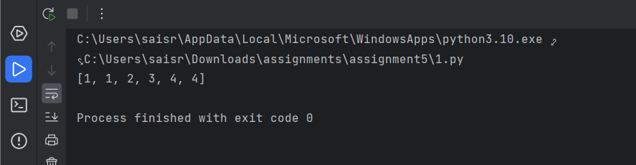Merge k Sorted Lists

**You are given an array of k linked-lists lists, each linked-list is sorted in ascending order. *Merge all the linked-lists into one sorted linked-list and return it.***

Coding:

class Node:

def init (self,data=None): self.data = data self.next = None

class Linked_list:

def init (self): self.head = None

def insert(self,data): new_node = Node(data) if not self.head:

self.head = new_node else:

current = self.head while current.next:

current = current.next current.next = new_node

return self.head

def s(self):

data = []

current = self.head while current:

data.extend(current.data) current = current.next

r = sorted(data) return r

ar = [[1,4,5],[1,3,4],[2,6]]

l = Linked_list()

for i in range(len(ar)): l.insert(ar[i])

print(l.s())

Output:

1. Remove Duplicates from Sorted Array

# Given an integer array nums sorted in non-decreasing order, remove the duplicates inplace such that each unique element appears only once. The relative order of the elements should be kept the same. Since it is impossible to change the length of the array in some languages, you must instead have the result be placed in the first part of the array nums. More formally, if there are k elements after removing the duplicates, then the first k elements of nums should hold the final result. It does not matter what you leave beyond the first k elements. Return k *after placing the final result in the first* k *slots of* nums.

Coding:

nums = [1,1,2] ar =[] underscore = "_"

for i in range(len(nums)): if i+1 <= len(nums)-1:

if nums[i] == nums[i+1] : if nums[i] is not ar:

ar.append(str(nums[i])) ar.append(underscore)

else:

ar.append(str(nums[i]))

print(sorted(ar)) n=[]

for i in range(len(ar)): if ar[i] != "_":

n.append(ar[i])

print(len(n))

Output:

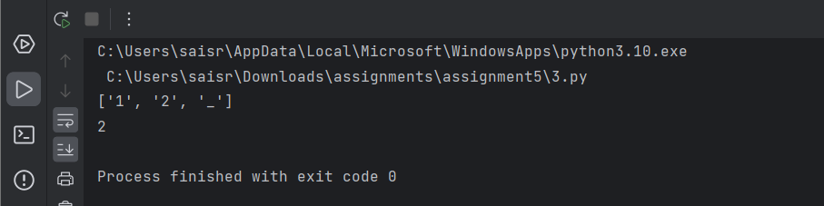

1. Search in Rotated Sorted Array

# There is an integer array nums sorted in ascending order (with distinct values).

**Prior to being passed to your function, nums is possibly rotated at an unknown pivot index k (1 <= k < nums.length) such that the resulting array is [nums[k], nums[k+1], ..., nums[n-1], nums[0], nums[1], ..., nums[k-1]] (0-indexed). For example, [0,1,2,4,5,6,7] might be rotated at pivot index 3 and become [4,5,6,7,0,1,2].**

Coding:

nums = [4, 5, 6, 7, 0, 1, 2]

target = 0 c=0

ans=0

for i in range(len(nums)): if nums[i]==target:

c=1 ans=i break

if c==0:

print("-1") else:

print(ans)

Output:

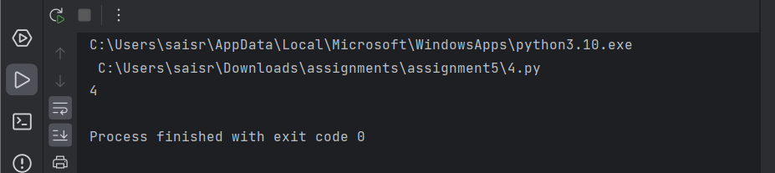

1. Find First and Last Position of Element in Sorted Array

# Given an array of integers nums sorted in non-decreasing order, find the starting and ending position of a given target value.If target is not found in the array, return [-1, -1].

Coding:

nums = [5,7,7,8,8,10]

target = 8 ar=[]

for i in range(len(nums)): if nums[i]==target:

ar.append(i) print(ar)

Output:

1. Sort Colors

# Given an array nums with n objects colored red, white, or blue, sort them in-place so that objects of the same color are adjacent, with the colors in the order red, white, and blue.We will use the integers 0, 1, and 2 to represent the color red, white, and blue, respectively. You must solve this problem without using the library's sort function.

Coding:

nums = [2, 0, 2, 1, 1, 0]

n = len(nums)

for i in range(n):

for j in range(0, n - i - 1): if nums[j] > nums[j + 1]:

nums[j], nums[j + 1] = nums[j + 1], nums[j]

print(nums)

Output:

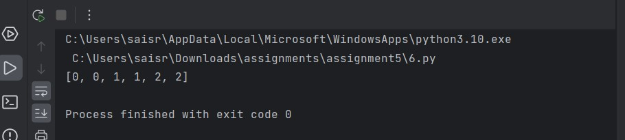

1. Remove Duplicates from Sorted List

**Given the head of a sorted linked list, *delete all duplicates such that each element appears only once*. Return *the linked list sorted as well*.**

Coding:

class Node:

def init (self, data=None): self.data = data

self.next = None

class Linked_list:

def init (self): self.head = None

def insert(self, data): new_node = Node(data) if not self.head:

self.head = new_node else:

current = self.head while current.next:

current = current.next current.next = new_node

return self.head

def dup(self): data = []

current = self.head while current:

data.append(current.data) current = current.next

i = 0

while i < len(data) - 1:

if data[i] == data[i + 1]: data.pop(i)

else:

i += 1

return data

ar = [1, 1, 2]

l = Linked_list()

for i in range(len(ar)): l.insert(ar[i])

print(l.dup())

Output:

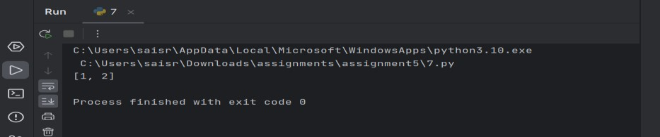

1. Merge Sorted Array

# You are given two integer arrays nums1 and nums2, sorted in non-decreasing order, and two integers m and n, representing the number of elements in nums1 and nums2 respectively.

Coding:

def merge(nums1, m, nums2, n):

p1, p2, p = m - 1, n - 1, m + n - 1 while p2 >= 0:

if p1 >= 0 and nums1[p1] > nums2[p2]: nums1[p] = nums1[p1]

p1 -= 1

else:

nums1[p] = nums2[p2] p2 -= 1

p -= 1

return nums1

nums1 = [1, 2, 3, 0, 0, 0]

m = 3

nums2 = [2, 5, 6]

n = 3

result = merge(nums1, m, nums2, n) print(result)

Output:

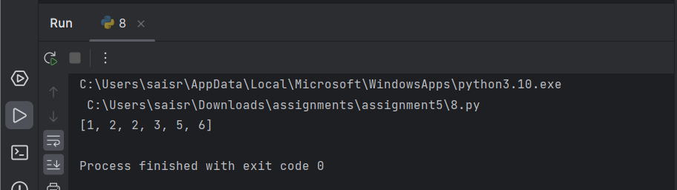

1. Convert Sorted Array to Binary Search Tree

# Given an integer array nums where the elements are sorted in ascending order, convert

***it to a height-balanced binary search tree*.**

Coding:

class Node:

def init (self, key): self.key = key self.left = None self.right = None

def sorte(nums): if not nums:

return None

mid = len(nums) // 2 root = Node(nums[mid])

root.left = sorte(nums[:mid]) root.right = sorte(nums[mid + 1:]) return root

def in_order(root): elements = []

_in_order(root, elements) return elements

def _in_order(root, elements): if root:

_in_order(root.left, elements) elements.append(root.key)

_in_order(root.right, elements)

nums = [1, 2, 3, 4, 5, 6, 7]

bst_root = sorte(nums)

print("In-order Traversal of the BST:", in_order(bst_root))

Output:

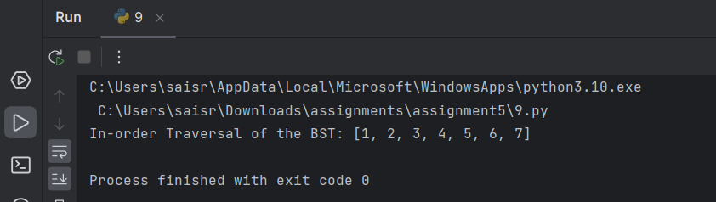

1. Insertion Sort List

# Given the head of a singly linked list, sort the list using insertion sort, and return *the sorted list's head*.

Coding:

class ListNode:

def init (self, val=0, next=None): self.val = val

self.next = next

def insertionSortList(head): dummy = ListNode(0)

curr = head while curr:

prev = dummy

while prev.next and prev.next.val < curr.val: prev = prev.next

next_temp = curr.next curr.next = prev.next prev.next = curr

curr = next_temp return dummy.next

def create_linked_list(values): if not values:

return None

head = ListNode(values[0]) current = head

for value in values[1:]: current.next = ListNode(value) current = current.next

return head

def linked_list_to_list(head): result = []

current = head while current:

result.append(current.val) current = current.next

return result

values = [4, 2, 1, 3]

head = create_linked_list(values) sorted_head = insertionSortList(head)

print("Sorted Linked List:", linked_list_to_list(sorted_head))

Output:

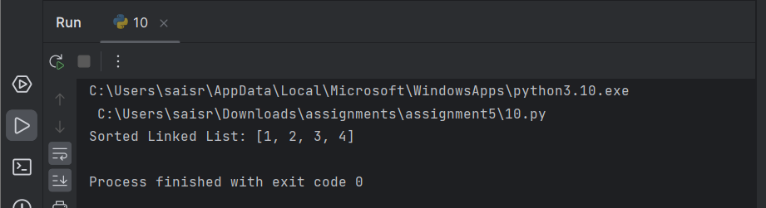

1. Sort Characters By Frequency

# Given a string s, sort it in decreasing order based on the frequency of the characters. The frequency of a character is the number of times it appears in the string.

**Return *the sorted string*. If there are multiple answers, return *any of them*.**

Coding:

from collections import Counter

def fsort(s):

freq = Counter(s)

chars = sorted(freq.items(), key=lambda x: x[1], reverse=True) result = ''.join([char * count for char, count in chars]) return result

s = "tree" print(fsort(s))

Output:

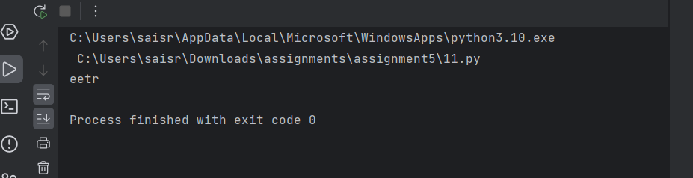

# Example 1:

**Input: head = [4,2,1,3] Output: [1,2,3,4]**

Coding:

class ListNode:

def init (self, val=0, next=None): self.val = val

self.next = next

def insertionSortList(head): dummy = ListNode() dummy.next = head

prev = dummy curr = head

while curr:

if curr.next and curr.next.val < curr.val:

while prev.next and prev.next.val < curr.next.val: prev = prev.next

temp = prev.next prev.next = curr.next

curr.next = curr.next.next prev.next.next = temp

prev = dummy else:

curr = curr.next return dummy.next

def create_linked_list(values): if not values:

return None

head = ListNode(values[0]) current = head

for value in values[1:]: current.next = ListNode(value) current = current.next

return head

def linked_list_to_list(head): result = []

current = head while current:

result.append(current.val) current = current.next

return result

values = [-1, 5, 3, 4, 0]

head = create_linked_list(values) sorted_head = insertionSortList(head)

print("Sorted Linked List:", linked_list_to_list(sorted_head))

Output:

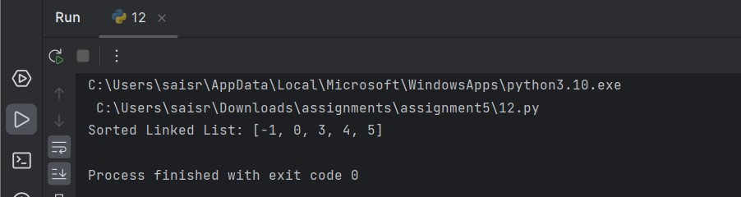

1. Max Chunks To Make Sorted

# You are given an integer array arr of length n that represents a permutation of the integers in the range [0, n - 1].We split arr into some number of chunks (i.e., partitions), and individually sort each chunk. After concatenating them, the result should equal the sorted array. Return *the largest number of chunks we can make to sort the array*

Coding:

def max_chunks_to_sorted(arr): max_val = 0

chunks = 0

for i, num in enumerate(arr): max_val = max(max_val, num)

if i == max_val: chunks += 1

return chunks

# Example usage

arr1 = [4, 3, 2, 1, 0]

arr2 = [1, 0, 2, 3, 4]

print("Example 1 Output:", max_chunks_to_sorted(arr1)) # Output: 1 print("Example 2 Output:", max_chunks_to_sorted(arr2)) # Output: 4

Output:

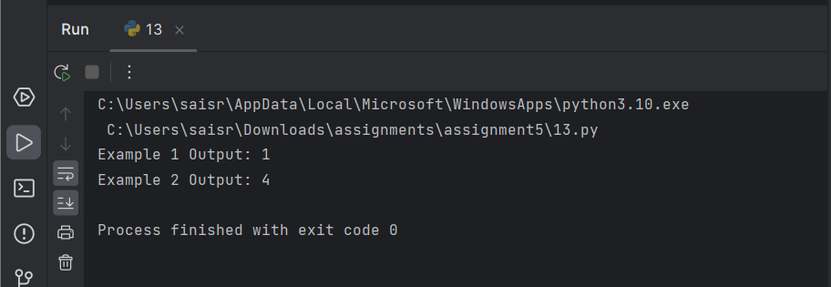

14 Intersection of Three Sorted Arrays

# Given three integer arrays arr1, arr2 and arr3 sorted in strictly increasing order, return a sorted array of only the integers that appeared in all three arrays.

Coding:

def intersection_of_three_arrays(arr1, arr2, arr3): result = []

p1, p2, p3 = 0, 0, 0

while p1 < len(arr1) and p2 < len(arr2) and p3 < len(arr3): if arr1[p1] == arr2[p2] == arr3[p3]:

result.append(arr1[p1]) p1 += 1

p2 += 1

p3 += 1

elif arr1[p1] < arr2[p2]: p1 += 1

elif arr2[p2] < arr3[p3]: p2 += 1

else:

p3 += 1

return result

# Example usage

arr1 = [1, 2, 3, 4, 5]

arr2 = [1, 2, 5, 7, 9]

arr3 = [1, 3, 4, 5, 8]

print("Example 1 Output:", intersection_of_three_arrays(arr1, arr2, arr3)) # Output: [1, 5]

arr1 = [197, 418, 523, 876, 1356]

arr2 = [501, 880, 1593, 1710, 1870]

arr3 = [521, 682, 1337, 1395, 1764]

print("Example 2 Output:", intersection_of_three_arrays(arr1, arr2, arr3)) # Output: []

Output:

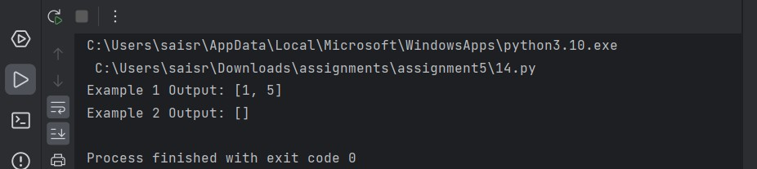

15. Sort the Matrix Diagonally

# A matrix diagonal is a diagonal line of cells starting from some cell in either the topmost row or leftmost column and going in the bottom-right direction until reaching the matrix's end. For example, the matrix diagonal starting from mat[2][0], where mat is a 6 x 3 matrix, includes cells mat[2][0], mat[3][1], and mat[4][2].

Coding:

def diagonalSort(mat):

m, n = len(mat), len(mat[0]) diagonals = {}

for i in range(m):

for j in range(n):

if (i - j) not in diagonals: diagonals[i - j] = []

diagonals[i - j].append(mat[i][j])

for key in diagonals: diagonals[key].sort()

for i in range(m):

for j in range(n):

mat[i][j] = diagonals[i - j].pop(0) return mat

mat = [[3, 3, 1, 1], [2, 2, 1, 2], [1, 1, 1, 2]]

print("Output:", diagonalSort(mat))

Output:

